|  |
| --- |
| *Comet Park* |
| **Vision Document** |
| **SE 6387 Advanced Software Engineering Project**  **R.Z. Wenkstern**    ***02/18/2014*** |

|  |
| --- |
| **Group *B*** |
| **Arunkumar Manickam** |
| **Hariprasad Natarajan** |
| **Rekha Muthulakshmi Nachadalingam** |
| **Prasanna Venkatesh Venkitasamy** |

# 

# Revision History

|  |  |  |  |
| --- | --- | --- | --- |
| **Version** | **Date** | **Description** | **Authors** |
| 1.0 | 02/18/2014 | Completed initial draft | Prasanna Venkatesh |

Contents

Revision History ii

1. Introduction 1

2. Positioning 1

2.1. Business Opportunity 1

2.2. Problem Statement 1

2.3. Product Position Statement 1

2.4. Alternatives and Competition 2

3. User Description 2

3.1 User/Market Demographics 2

3.2 User Profiles 2

3.3 Key User Needs 3

3.4 User Environment 3

4. Product Overview 3

4.1 Product Perspective 3

4.2 Summary of Capabilities and benefits 4

4.3 Assumptions and Dependencies 4

4.4 Cost and Pricing 5

4.5 Licensing and Installation 5

Appendix A: Glossary 6

Appendix B: References 7

# **1. Introduction**

**1.1 Purpose**

The purpose of this document is to identify, analyze and define high-level needs and features of the CometPark System. It focuses on the needs and the problems faced by the stakeholders and the target users and how the CometPark system is an effective solution to these needs.

**1.2 Scope**

This Vision document applies to Comet Park System, which will be developed for use by the faculty and students of the University of Texas of Dallas.

# 2. Positioning

## 2.1. Business Opportunity

A major problem that the students and the staff of the University of Texas at Dallas face every day is finding a vacant parking spot on campus near to the building that they need to visit. Finding a parking space in the open lots, especially on the weekdays during class hours is a big challenge for those who commute by car and it is a problem that needs to be addressed. A lot of time and fuel is wasted in this process of finding an empty spot and results in frustration of the commuters. A parking spot locator system to help the UT Dallas community to solve their parking problems will be a welcome change.

## 2.2. Problem Statement

|  |  |
| --- | --- |
| The problem of | finding a vacant parking spot on the UTD campus |
| affects | all the staff and students who commute to UTD by car |
| the impact of which is | wasting a significant amount of time, gas and energy in finding a vacant parking spot to park their car |
| a successful solution would be | Implementing a Parking Management system that makes use of IoT devices together with mobile application to find a vacant parking spot. |

## 2.3. Product Position Statement

|  |  |
| --- | --- |
| For | The staff and students of UTD |
| Who | Face the problem of finding a vacant parking spot near the building they want to visit |
| The CometPark | Is a Parking Locator system |
| That | Displays the available parking spots in a lot to the user in their own smart phones |
| Unlike | Camera based systems and systems with huge display board that are expensive |
| Our system | Is a cost-effective solution that locates the exact vacant spots in a lot |

## 2.4. Alternatives and Competition

The alternative solutions that exist to the problem are the use of LED Display boards at the entrance of each parking lot that show the number of vacant spots available in the lot and status like Full/Half Full and Empty.

Another alternative is the use of cameras in each parking lot that scans the surrounding area and identifying the vacant spots by processing the image.

Both of the alternatives mentioned above are much expensive compared to our proposed system, the CometPark and neither of them locates the exact vacant spots in a lot. The LED Display boards show only the status of a lot and the solution with the camera requires a high degree of image processing to be done to give accurate results.

# 3. User Description

## 3.1 User/Market Demographics

Almost all students and staff members who commute to UTD via car face the problem of finding a parking spot to park their car. Out of those, the people who have Android Smartphone are the target audience.

## 3.2 User Profiles

|  |  |
| --- | --- |
| **Users** | **Description** |
| Students | General term used for person who attends UTD |
| Administrative Staffs | General term used for someone employed by UTD |
| Administrator | Term for the individual who is responsible for maintaining the Comet Park system. |

## 3.3 Key User Needs

The key user needs are as follows:

1. A system that helps the user to find an available parking spot on campus near to the building that they wish to visit.
2. A system that is cost effective and does not require much effort from the user.

## 3.4 User Environment

The typical user environment for the system is within the UTD campus, particularly around the parking lots near the buildings. The target users are the students who arrive at the campus by car and park their vehicles in the open parking lots. The CometPark system is not a business critical application and the interruptions in the service of the system will not affect the user’s business.

# 4. Product Overview

4.1 Product Perspective

The following is a system context diagram of the CometPark system and it gives an overview of the various components of the system and their interactions.

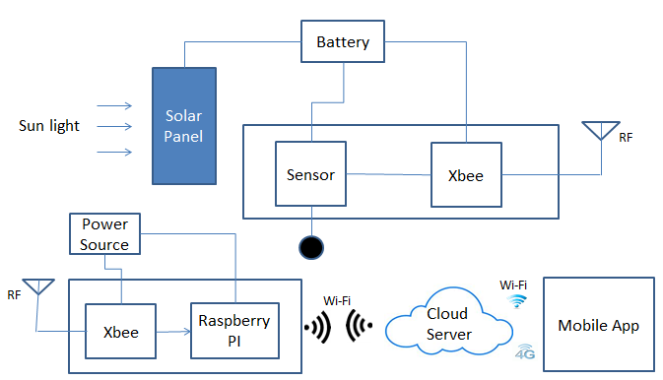

## 4.2 Summary of Capabilities and benefits

The following table is a summary of the key features that the CometPark system offers and the benefits that the users get from the features.

|  |  |
| --- | --- |
| **Feature** | **User Benefit** |
| Finding nearest vacant parking spot for a user | The user can significantly reduce the time and effort in searching for vacant parking spot |
| Manage the closure of some of the parking lots in case of events and occasions. | The Administrator can inform the closure of a parking lot through the system instead of using other means like printing notices, sending e-mail to everyone in the university including those who do not commute via car. |
| Provide options to the user to find parking spots with the preferred color code. | Users can view only the available spots associated with the color of their parking permit. |
| Manage the closure of all parking lots in case of emergencies. | The user is notified of the emergency situation and the non-availability of parking spaces on campus. This helps the user to decide on their travel options to the campus. |

## 4.3 Assumptions and Dependencies

* The users should have a smart phone with data plan and GPS activated.
* In open parking lots where the wiring facility is not very extensive, the system must have as little or no wiring as possible.
* The Controllers used by the CometPark system should be able to connect to the University Wi-Fi (CometNet).
* The connection to CometNet wireless network from the controller should not have any timeout.
* The parking lots have access to a power source, preferably a renewable energy source.
* The application will be hosted on a cloud server(AWS) and the availability of the application is dependent on the availability of the web server.
* The cost and timelines described for this project are based on the estimates for a small number of parking spaces in a single parking lot. Implementing the system on a large scale will have a different budget and timeline.

## 4.4 Cost and Pricing

The total budget for the Comet Park system is $200. The estimated cost for implementing the system per parking space is:

Cost per parking space: $28.57

Cost per controller component: $69.97(which will be shared by multiple parking sources in a lot)

## 4.5 Licensing and Installation

The System shall require acquiring license to use AWS as server and installation of the same.

# Appendix A: Glossary

|  |  |
| --- | --- |
| **Term** | **Definition** |
| **UTD** | **University of Texas at Dallas** |
| **IoT** | **Internet of Things** |
| **AWS** | **Amazon Web Services** |

# Appendix B: References

1. <http://pic.dhe.ibm.com/infocenter/clmhelp/v4r0/index.jsp?topic=%2Fcom.ibm.rational.rrm.help.doc%2Ftopics%2Fr_vision_doc.html>